### FINAL PROJECT REPORT

ON

# “E-COMMERCE WEBSITE”

Submitted in partial fulfillment of the requirements for the award of degree of

**BACHELOR OF ENGINEERING IN**

**COMPUTER SCIENCE & ENGINEERING**



**Submitted to: Ms. Akamdeep Kaur Grewal**

**Submitted By:**

Nishchita Jagadish(20BCS5764)

Kamini Verma(20BCS5839)

Maulik Bhatnagar(20BCS5814)

Tanmay Srivastava(20BCS5840)

##### DEPARTMENT OF COMPUTER SCIENCE & ENGINEERING

**Chandigarh University, Gharuan**

##### CERTIFICATE

This is to certify that the work embodied in this Project Report entitled **“**E-COMMERCE WEBSITE**”**, being submitted by “20BCS5764, 20BCS5839, 20BCS5814, 20BCS5840” 3rd

Semester for partial fulfillment of the requirement for the degree of **“Bachelor of Engineering in Computer Science & Engineering”, discipline in “Chandigarh University”** during the academic session JUNE JULY-2021 is a record of bona fide piece of work, carried out by student under my supervision and guidance in the **“Department of Computer Science & Engineering”, Chandigarh University.**

##### DECLARATION

We, students of Bachelor of Engineering in Computer Science & Engineering, 3rd Semester, session: JUNE JULY-2021, Chandigarh University, hereby declare that the work presented in this Project Report entitled “E-COMMERCE WEBSITE” is the outcome of our own work, is bona fide and correct to the best of our knowledge and this work has been carried out taking care of Engineering Ethics. The work presented does not infringe any patent work and has not been submitted to any other university or anywhere else for the award of any degree or any professional diploma.

**Student’s details and Signature**

Nishchita Jagadish (20BCS5764)

Kamini Verma (20BCS5839)

Maulik Bhatnagar (20BCS5814)

Tanmay Srivastava (20BCS5840)

**APPROVED & GUIDED BY:**

To our Project In charge “Ms. Akamdeep Kaur Grewal”.

##### ACKNOWLEDGEMENT

We would like to express our deep and sincere gratitude to our Project In charge **Akamdeep Kaur Grewal** for giving us the opportunity to do the project and providing valuable guidance throughout this research. Their dynamism, vision and exquisite efforts have deeply inspired us. They taught us the methodology to carry out the research and to present the research work as clearly as possible. It was a great privilege for us to study and work under their guidance.

We owe the completion of my project to our project Mentor for her continuous support and guidance.

### ABSTRACT

Our aim is to design and develop an online shopping website using open source technologies (PHP, HTML5, CSS, JavaScript, MySQL and Apache Web Server) for products in India where customers will be able to buy products online.

The designed application contains a main home page which is displaying the featured products and other services, a products page which displays the various products the website has to offer ranging from electronics, fashion movies and more. The about page containing the creators information, a contact us page which will allow users to get in touch with the creators with feedback, tips, etc. And finally an accounts page which contains a registration form which when filled stores the customer’s details into a database which can be viewed by the admin.

The purpose of this system is to develop a web site for the people who can book their products from any part of the world.

# LIST OF FIGURES

|  |  |  |
| --- | --- | --- |
| S NO. | FIGURE NAME | PAGE NO. |
| 1. | Web Site Diagram | 11 |
| 2. | Programming Language Popularity by Github Projects Diagram | 12 |
| 3. | Database Server Diagram | 13 |
| 4. | Snapshots of Project | 14-19 |
| 6. | Snapshots of Coding Required | 20-23 |

# Table of Contents

**Topic Page No.**

Certificate 02

Students ’s Declaration 03

Acknowledgement 04

Abstract 05

List of Figures 06

CHAPTER 1 INTRODUCTION 07-09

* 1. Theoretical explanation 06-07
  2. Software and Hardware tools required for project 07-09

CHAPTER 2 TRAINING WORK UNDERTAKEN, CONTRIBUTION 09-12

* 1. UI Development 09-10
  2. Scripting 10-11
  3. Database 11-12

CHAPTER 3 RESULTS AND DISCUSSION 17-18

3.1 Result 17-18

3.2 Snapshots

3.3 Coding

CHAPTER 4 CONCLUSION AND FUTURE SCOPE 19-23

* 1. Conclusion 19-20
  2. Future Scope 21-23

### CHAPTER 1 INTRODUCTION

E-commerce (electronic commerce or EC) is the buying and selling of goods and services, or the transmitting of funds or data, over an electronic network, primarily the internet. These business transactions occur either as business-to-business, business-to-consumer, consumer-to-consumer or consumer-to-business. E-commerce shops have become part of our daily lives.

Technological advancement has made it possible for people to sit in the convenience of their homes and still shop online without going to a physical shop. Indians have also joined the trend of e-commerce business, so this project is meant to design an Ecommerce online shop so that the people in India will be able to purchase their goods and services online. The website contains a main home page which is displaying the featured products and other services, a products page which displays the various products the website has to offer ranging from electronics, fashion movies and more. The about page containing the creators information, a contact us page which will allow users to get in touch with the creators with feedback, tips, etc. And finally an accounts page which contains a registration form which when filled stores the customer’s details into a database which can be viewed by the admin.

This report contains Software and Hardware tools required for project in chapter one, sequential learning steps, methodology in chapter two, all figures of the screenshots of the website along with essential code in chapter three, and the conclusion and the future scope of the project in chapter four.

#### 1.2 Software and Hardware tools required for Project-

**Software:**

##### HTML

HTML stands for Hyper Text Markup Language**.** Itis the standard markup language for creating Web pages**.** It describes the structure of a Web page**.** It consists of a series of elements. HTML elements tell the browser how to display the content**.**HTML elements label pieces of content such as "this is a heading", "this is a paragraph", "this is a link", etc.

**Hypertext Markup Language** (**HTML**) is the standard [markup language](https://en.wikipedia.org/wiki/Markup_language) for documents designed to be displayed in a [web browser](https://en.wikipedia.org/wiki/Web_browser). It can be assisted by technologies such as [Cascading](https://en.wikipedia.org/wiki/Cascading_Style_Sheets) [Style Sheets](https://en.wikipedia.org/wiki/Cascading_Style_Sheets) (CSS) and [scripting languages](https://en.wikipedia.org/wiki/Scripting_language) such as [JavaScript](https://en.wikipedia.org/wiki/JavaScript).

##### CSS

CSS stands for Cascading Style Sheets. CSS describes how HTML elements are to be displayed on screen, paper, or in other media. CSS saves a lot of work. It can control the layout of multiple web pages all at once. External stylesheets are stored in CSS files

##### JAVASCRIPT

**JavaScript** often abbreviated as **JS**, is a [programming language](https://en.wikipedia.org/wiki/Programming_language) that conforms to the [ECMAScript](https://en.wikipedia.org/wiki/ECMAScript) specification. JavaScript is [high-level,](https://en.wikipedia.org/wiki/High-level_programming_language) often [just-in-time compiled](https://en.wikipedia.org/wiki/Just-in-time_compilation), and [multi-](https://en.wikipedia.org/wiki/Programming_paradigm) [paradigm.](https://en.wikipedia.org/wiki/Programming_paradigm) It has [curly-bracket syntax](https://en.wikipedia.org/wiki/List_of_programming_languages_by_type#Curly-bracket_languages), [dynamic typing,](https://en.wikipedia.org/wiki/Dynamic_typing) [prototype-based](https://en.wikipedia.org/wiki/Prototype-based_programming) [object-orientation](https://en.wikipedia.org/wiki/Object-oriented_programming), and [first-class functions.](https://en.wikipedia.org/wiki/First-class_function)

Alongside [HTML](https://en.wikipedia.org/wiki/HTML) and [CSS](https://en.wikipedia.org/wiki/CSS), JavaScript is one of the core technologies of the [World Wide](https://en.wikipedia.org/wiki/World_Wide_Web) [Web](https://en.wikipedia.org/wiki/World_Wide_Web)[.](https://en.wikipedia.org/wiki/JavaScript#cite_note-8) JavaScript enables interactive [web pages](https://en.wikipedia.org/wiki/Web_page) and is an essential part of [web applications](https://en.wikipedia.org/wiki/Web_application).

The vast majority of [websites](https://en.wikipedia.org/wiki/Website) use it for [client-side](https://en.wikipedia.org/wiki/Client-side) page behavior,and all major [web](https://en.wikipedia.org/wiki/Web_browser) [browsers](https://en.wikipedia.org/wiki/Web_browser) have a dedicated [JavaScript engine](https://en.wikipedia.org/wiki/JavaScript_engine) to execute it.

**PHP** is a [general-purpose](https://en.wikipedia.org/wiki/General-purpose_programming_language) [scripting language](https://en.wikipedia.org/wiki/Scripting_language) that is especially suited to [web development](https://en.wikipedia.org/wiki/Web_development). It was originally created by Danish-Canadian [programmer](https://en.wikipedia.org/wiki/Programmer) [Rasmus Lerdorf](https://en.wikipedia.org/wiki/Rasmus_Lerdorf) in 1994; the PHP [reference](https://en.wikipedia.org/wiki/Reference_implementation) [implementation](https://en.wikipedia.org/wiki/Reference_implementation) is now produced by The PHP Group. PHP originally stood for *Personal Home Page*,but it now stands for the [recursive initialism](https://en.wikipedia.org/wiki/Recursive_initialism) *PHP: Hypertext Preprocessor*.

##### MY SQL

SQL is a standard language for accessing and manipulating databases. SQL stands for Structured Query Language. SQL lets you access and manipulate databases. SQL became a standard of the American National Standards Institute (ANSI) in 1986, and of the International Organization for Standardization (ISO) in 1987

SQL can execute queries against a database, retrieve data, insert records in a database, update records ,delete records, create new databases, create new tables in a database, create stored procedures in a database, create views in a database, set permissions on tables, procedures, and views

Hardware:

* Processor (CPU) with 2 gigahertz (GHz) frequency or above
* A minimum of 2 GB of RAM
* Monitor Resolution 1024 X 768 or higher
* A minimum of 20 GB of available space on the hard disk .Internet Connection Broadband (high-speed) Internet connection with a speed of 4 Mbps.
* Keyboard and a Microsoft Mouse or some other compatible pointing device.

### 

### CHAPTER – 2

#### THE STEPS TO CREATE A WEB SITE AND CONTRIBUTION OF EACH STUDENT

Creating a web site requires multiple steps which includes the following:

* Creating a UI(User interface)
* Scripting(Both at server end and client end)
* Creating a backend or the database

### 

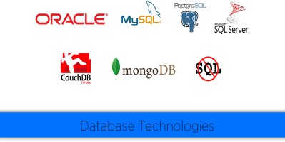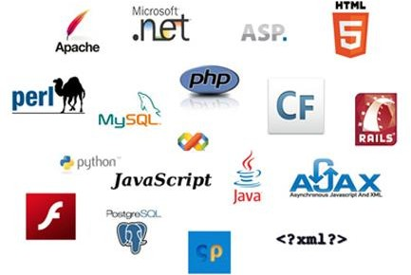

**Web Site**

**UI**

**Data Base**

**Fig 2.1**

#### UI DEVELOPMENT

Technologies that are mostly used to develop a User Interface are:

* + HTML
  + CSS
  + Bootstrap.

#### SCRIPTING

There are two scripting methodologies.

* + Server side scripting: This scripting is done at the server end
  + Client side scripting: This scripting is done at the client end or the browser.

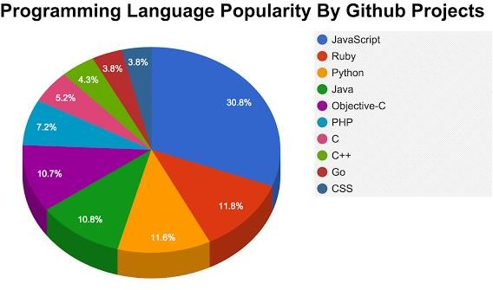

**Fig 2.2.1**

12 | P a g e

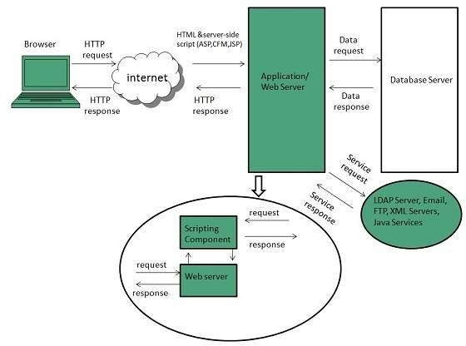

**Fig 2.2.2**

#### DATABASE

* + DBMS
  + MySQL
  + QUERIES

##### TEAM WORK –

**FRONTEND –** KAMINI, MAULIK

**BACKEND –** NISHCHITA, TANMAY

13 | P a g e

##### CHAPTER 3

##### RESULTS, SNAPSHOTS, CODING

**3.1 RESULT**

Therefore, after implementing all the mentioned libraries as well as software tools, we finally created our full-fledge website where users can make an account, log in, and browse the products of their choice, and give us their feedback.

**3.2 SNAPSHOTS**

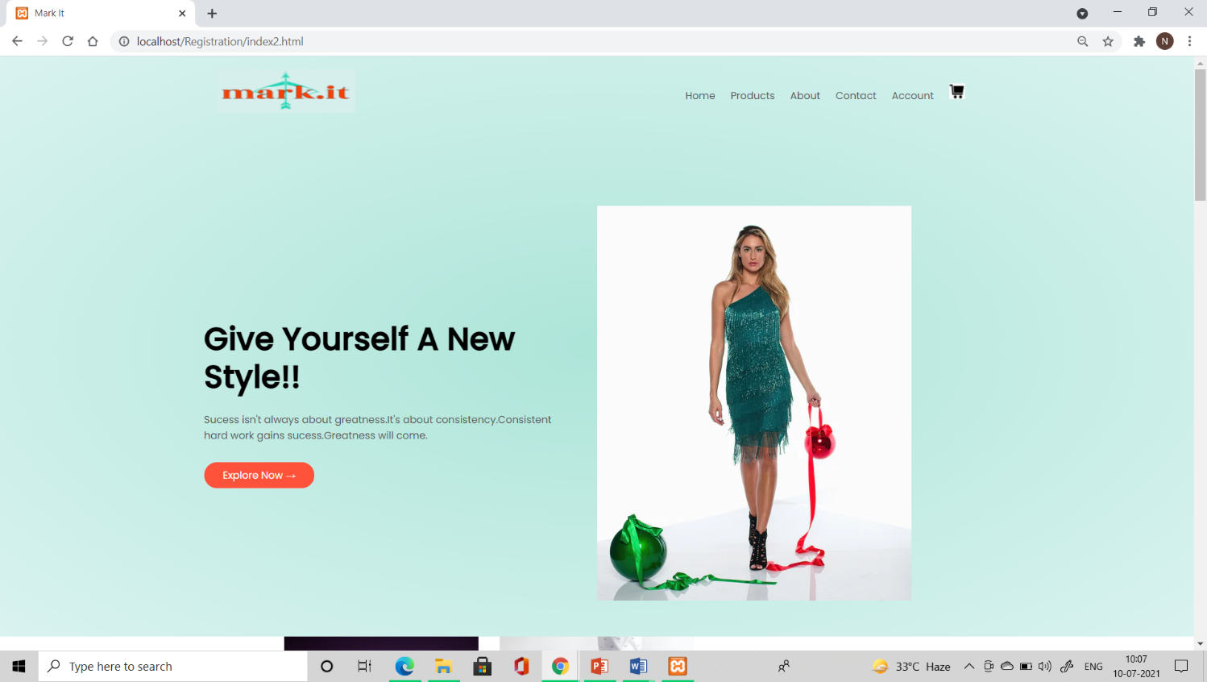

**Fig 3.2.1 Home Page**

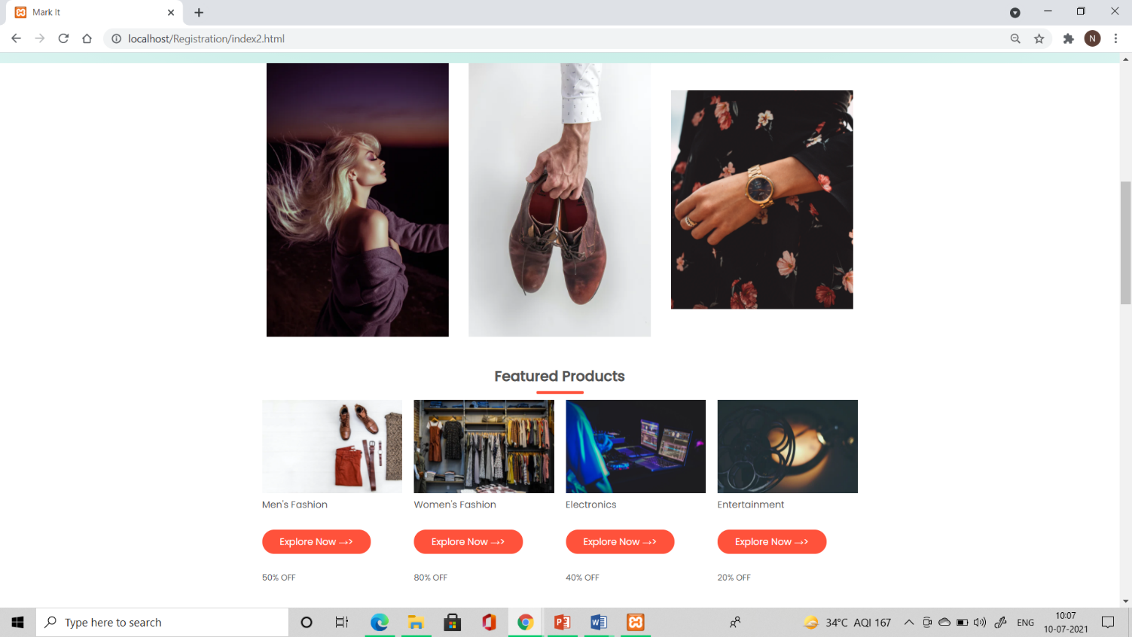

**Fig 3.2.2 Home Page**

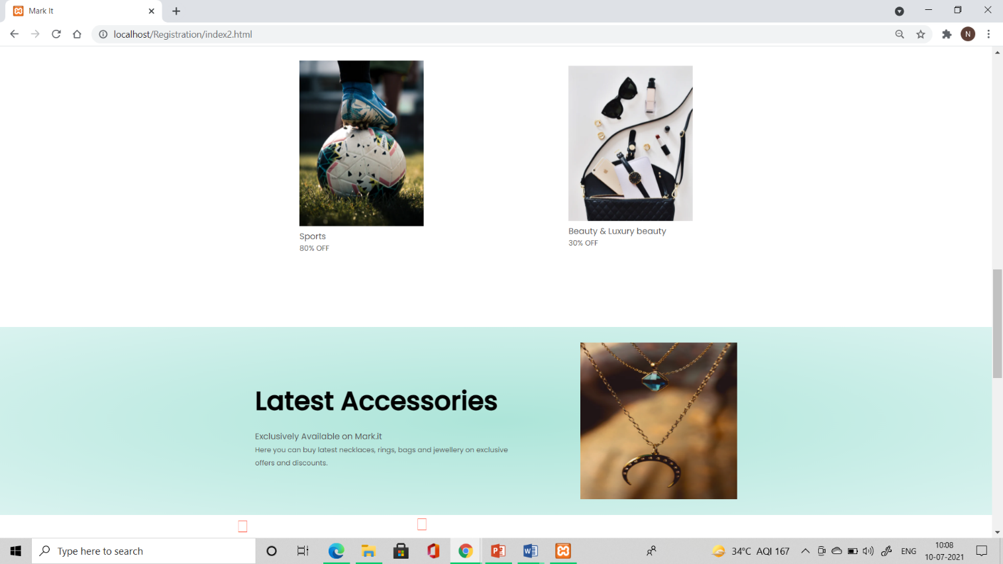

**Fig 3.2.3 Home Page**

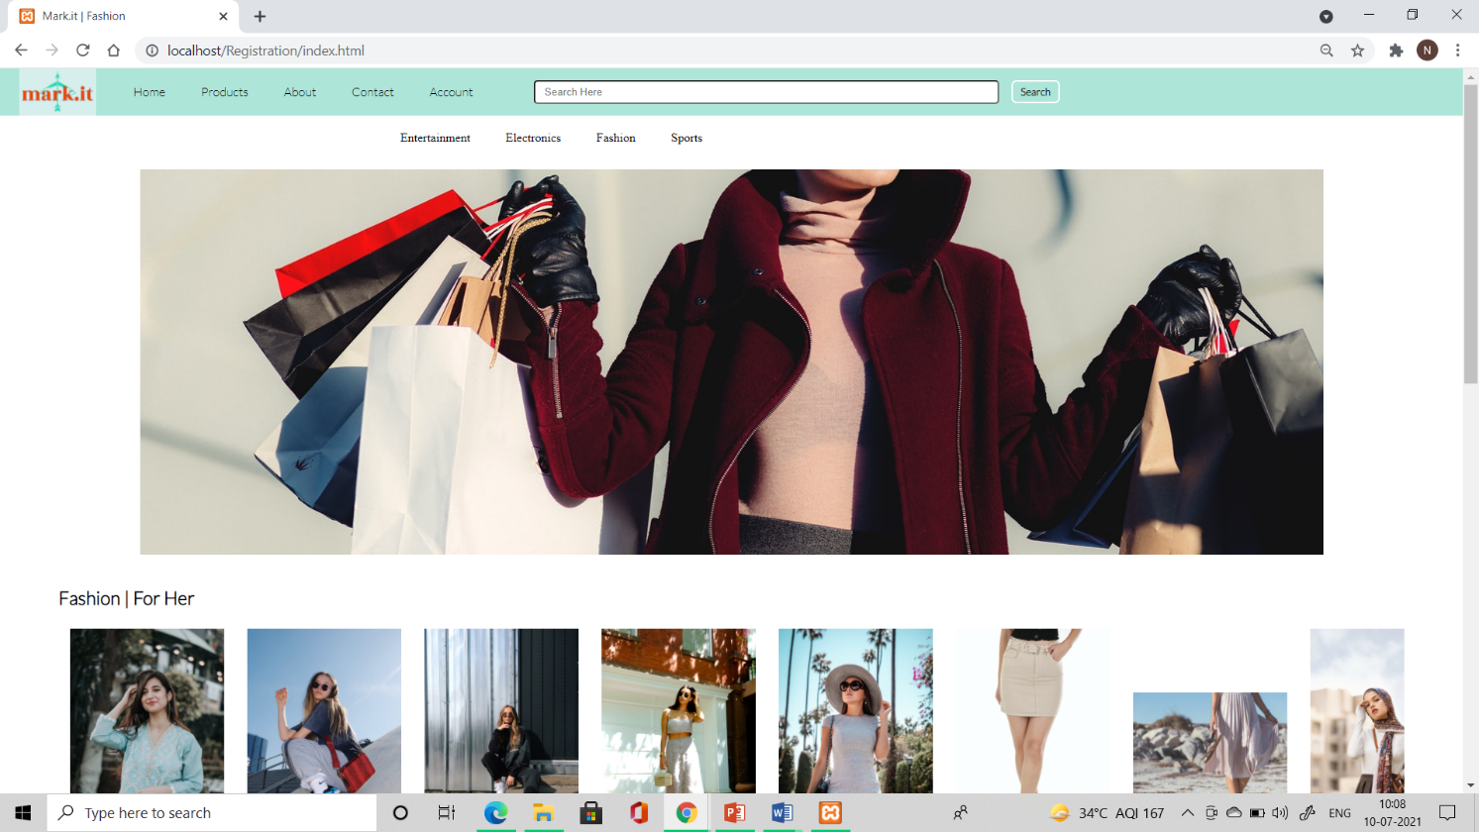

**Fig 3.2.4 Products page**

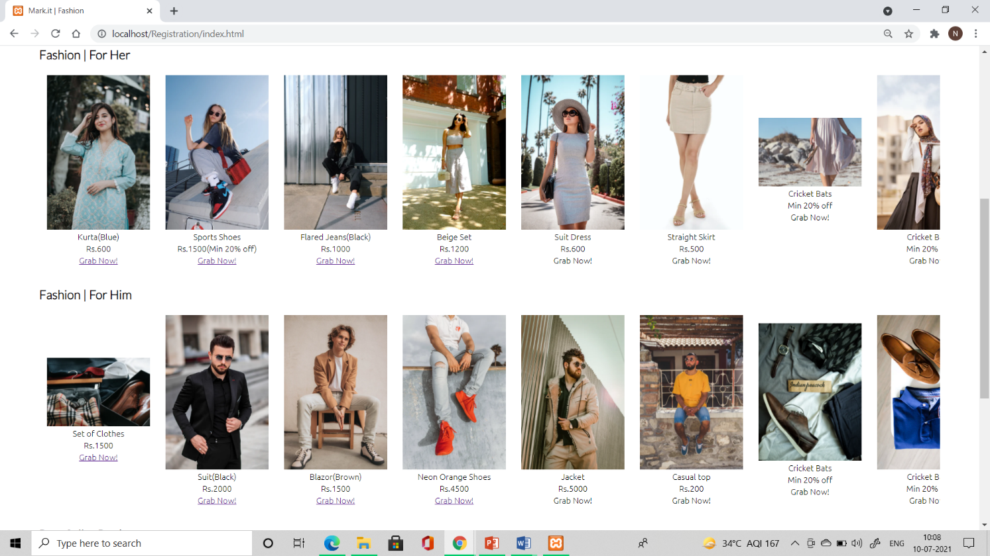

**Fig 3.2.5 Fashion**

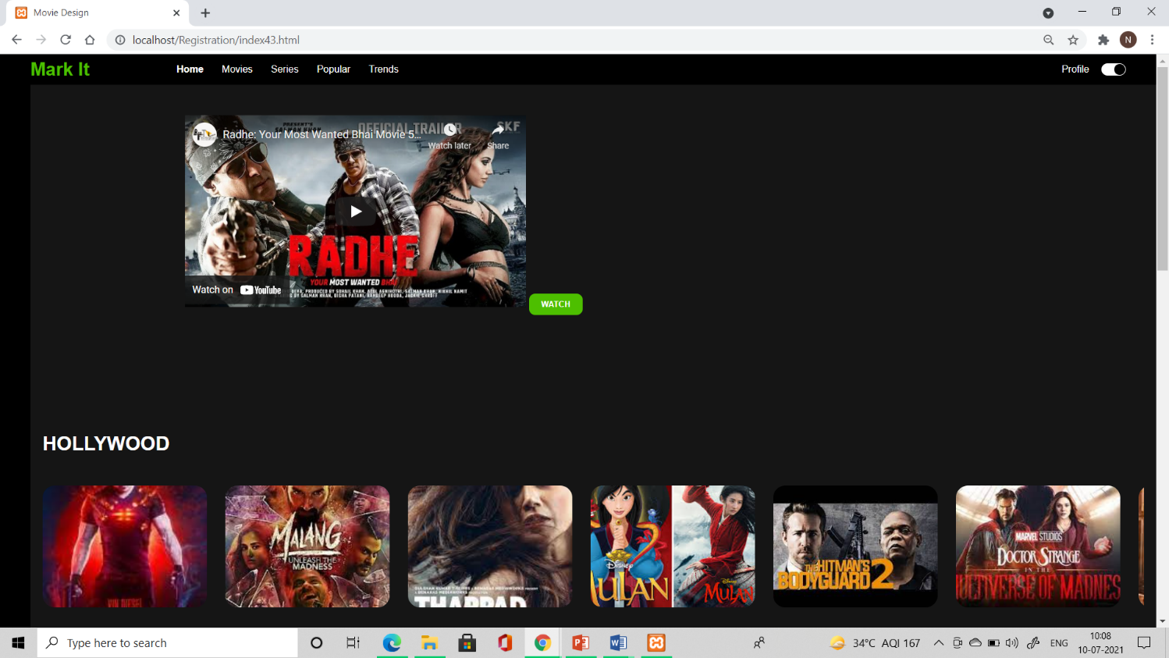

**Fig 3.2.6 Entertainment**

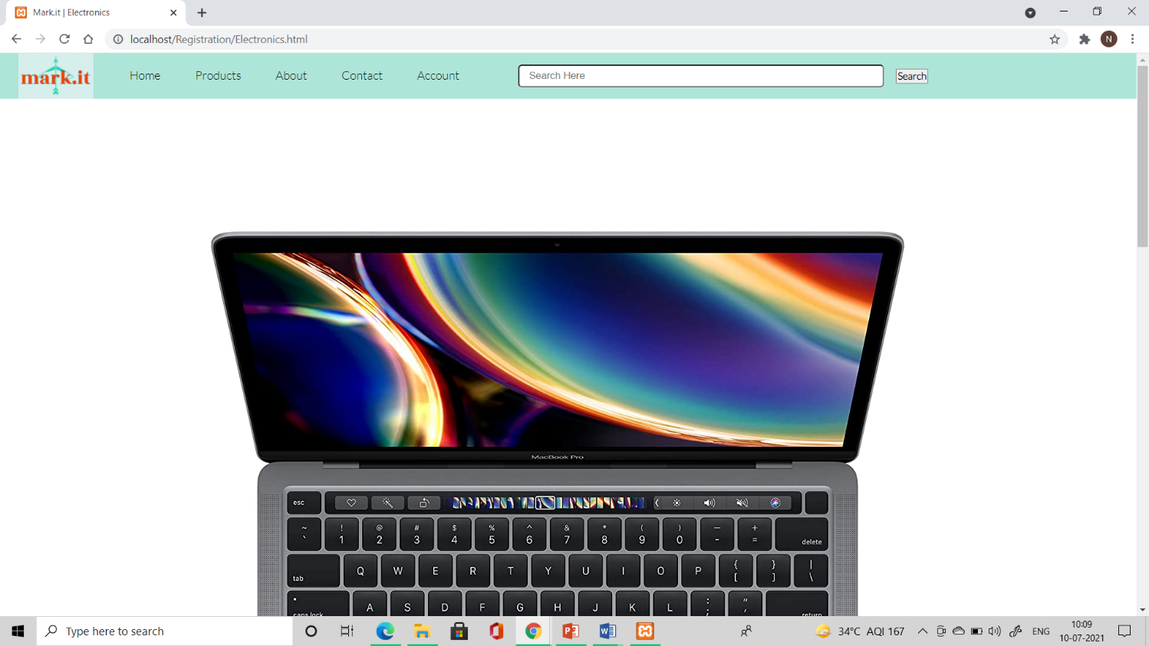

**Fig 3.2.7 Electronics**

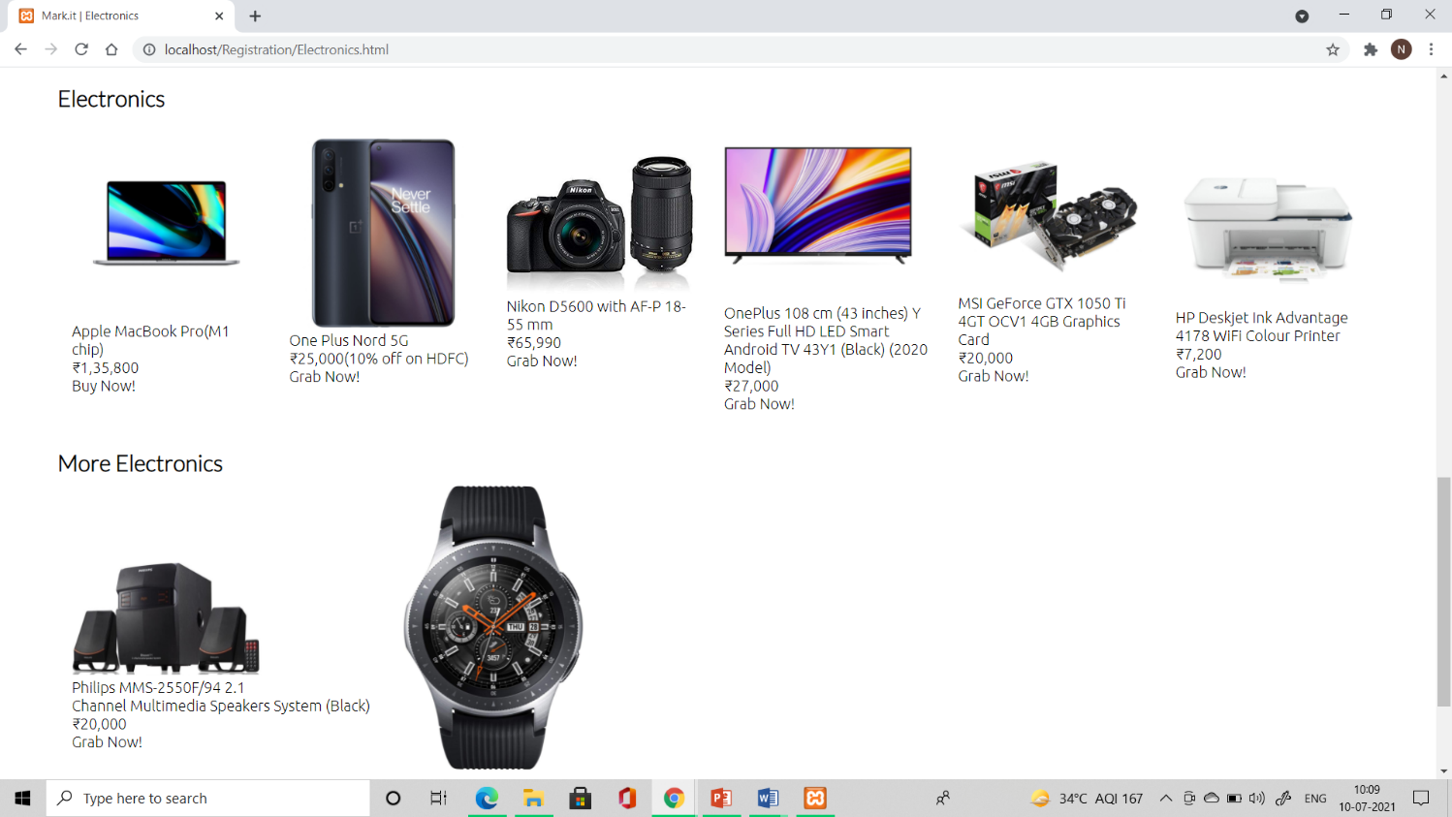

**Fig 3.2.8 Electronics**

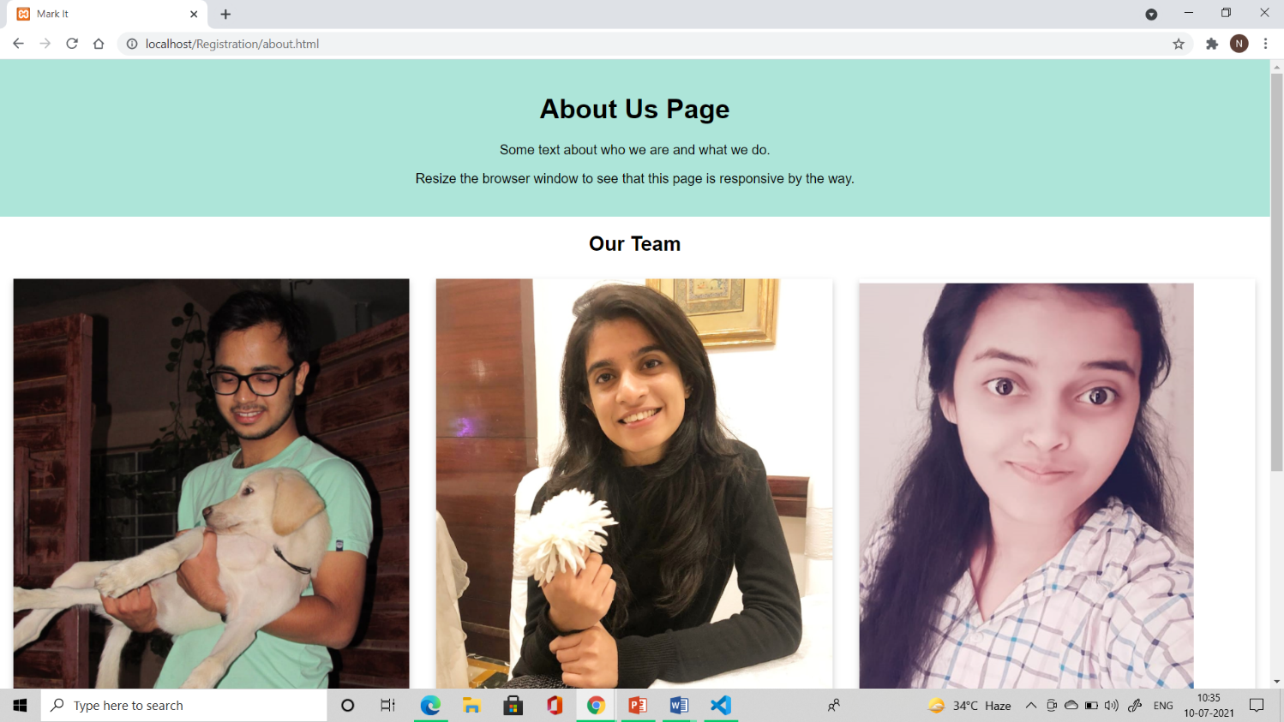

**Fig 3.2.9 About Us Page**

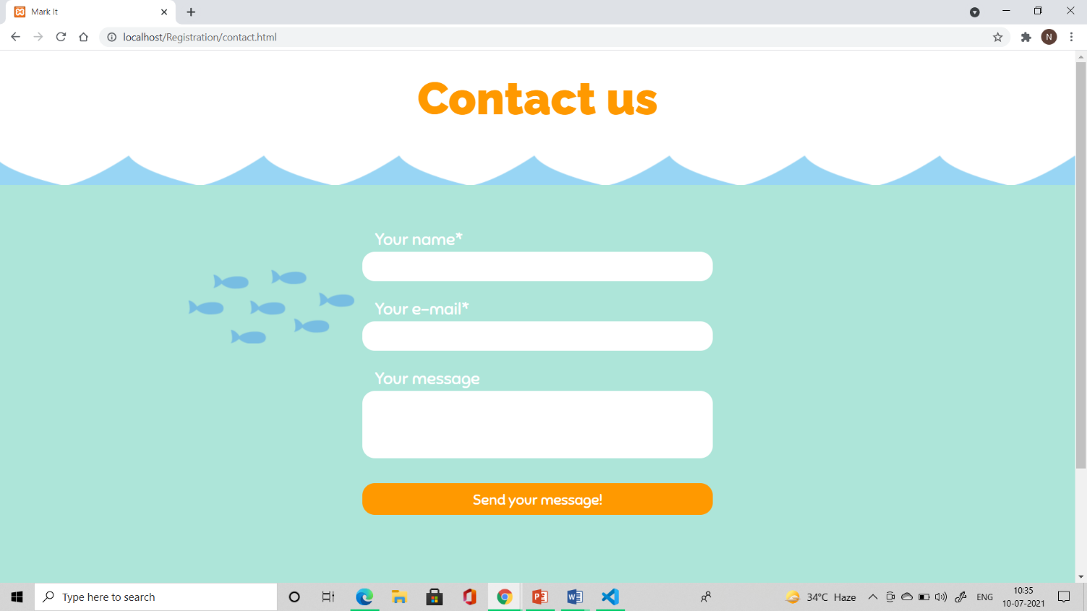

**Fig 3.2.10 Contact us page**

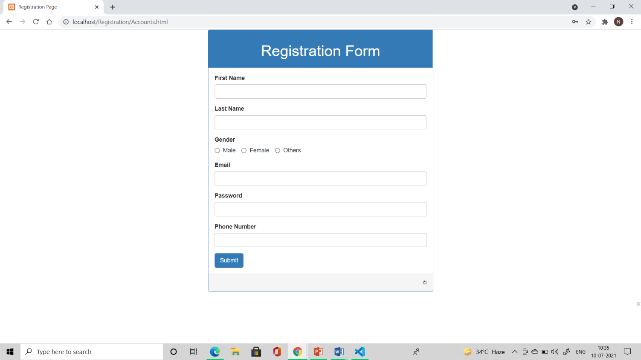

**Fig 3.2.11 Accounts page**

**3.3 CODING**

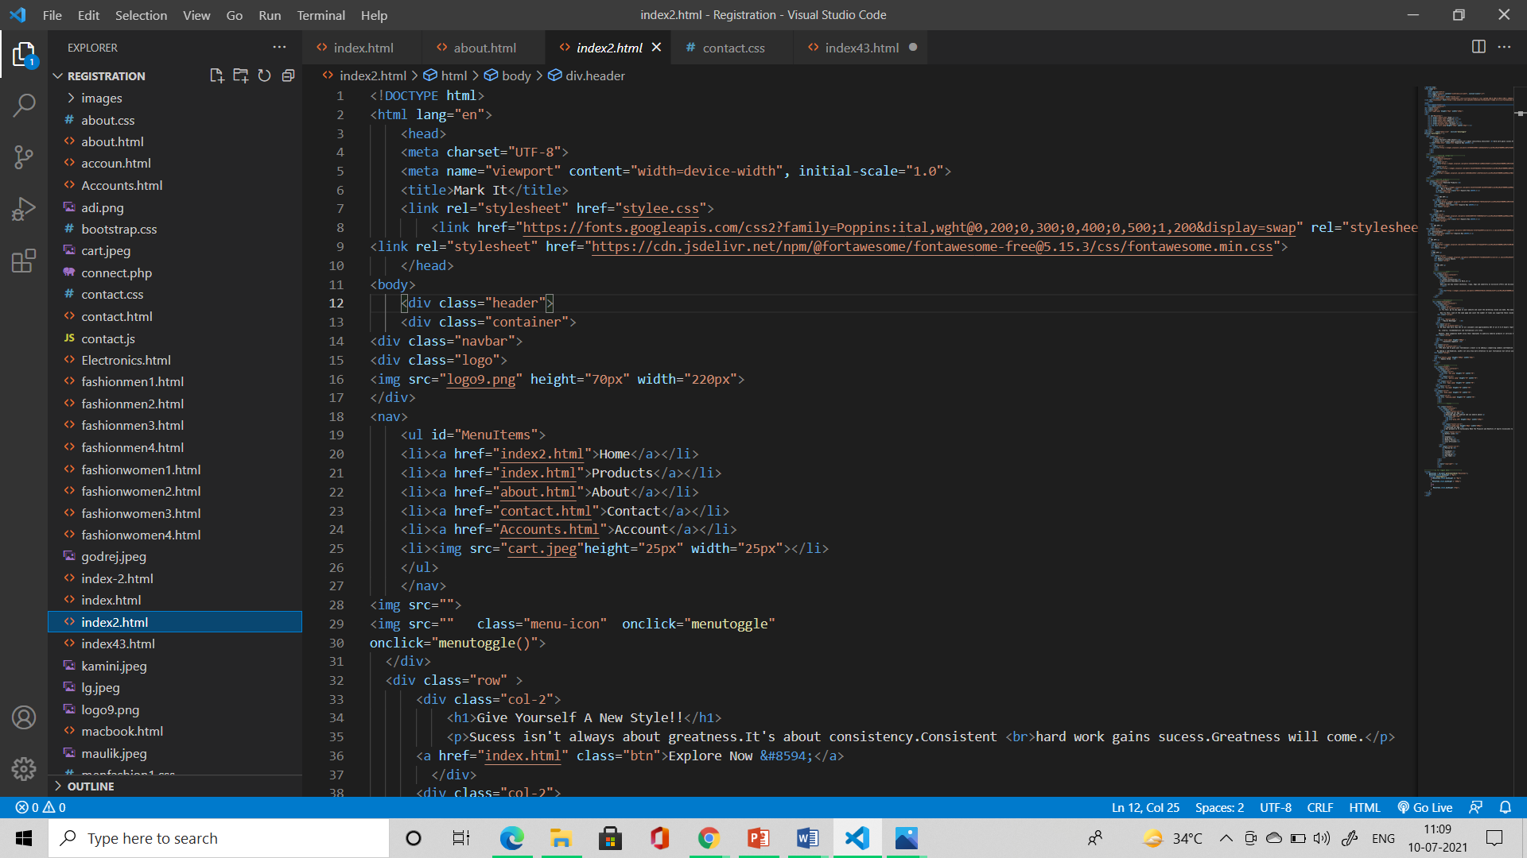

**Fig 3.3.1 Home**

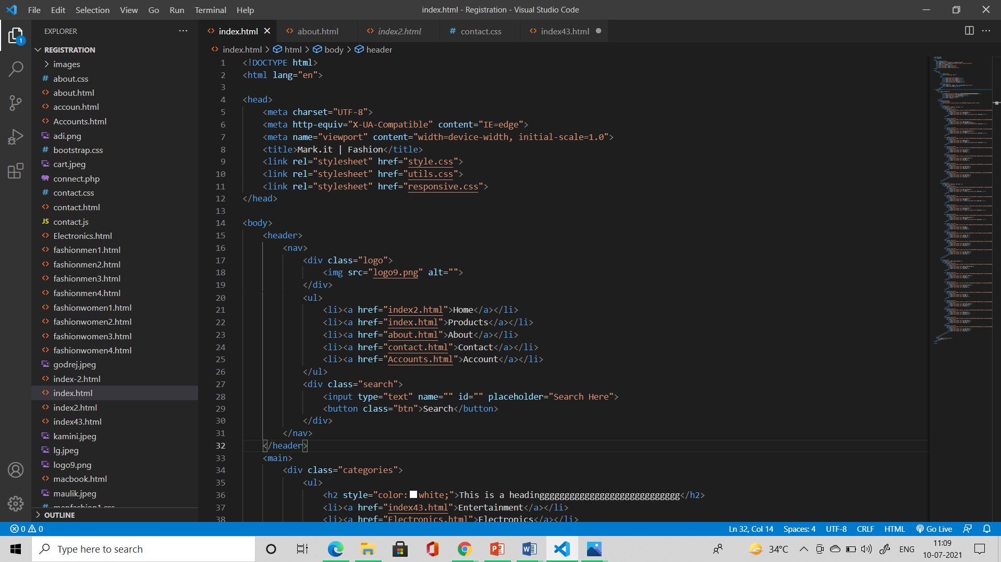

**Fig 3.3.2 Products**

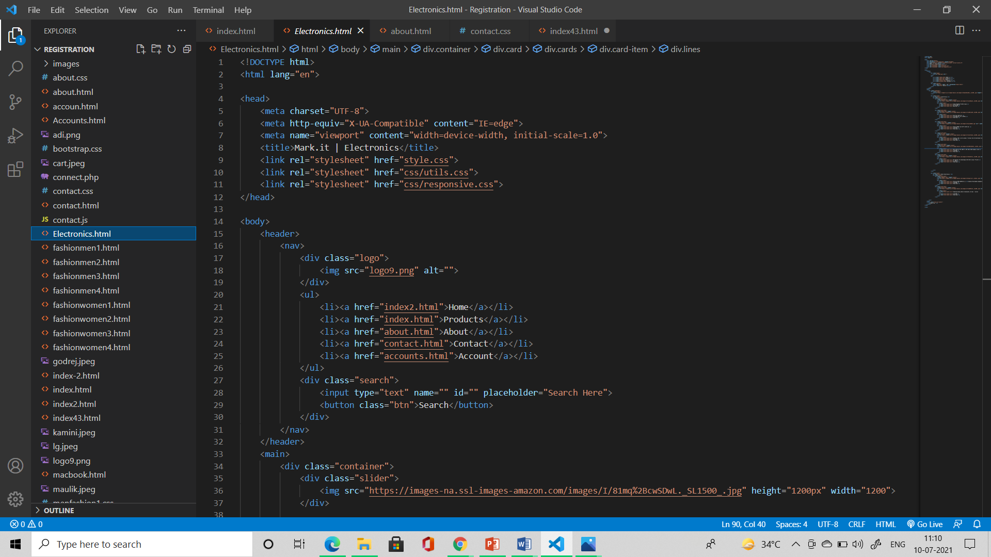

**Fig 3.3.3 Electronics**

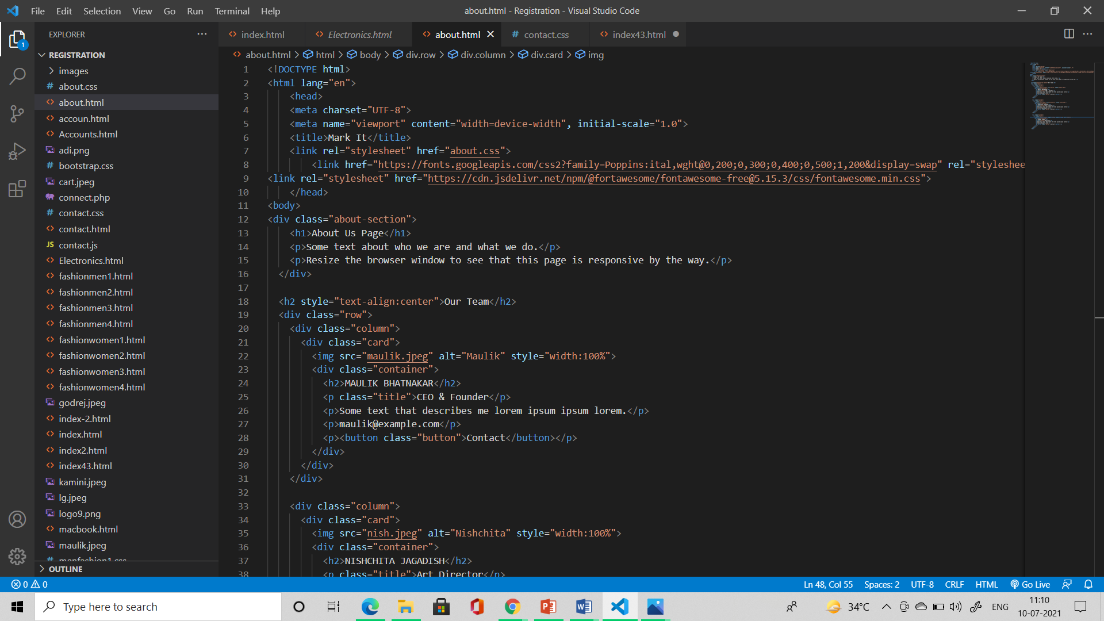

**Fig 3.3.4 About**

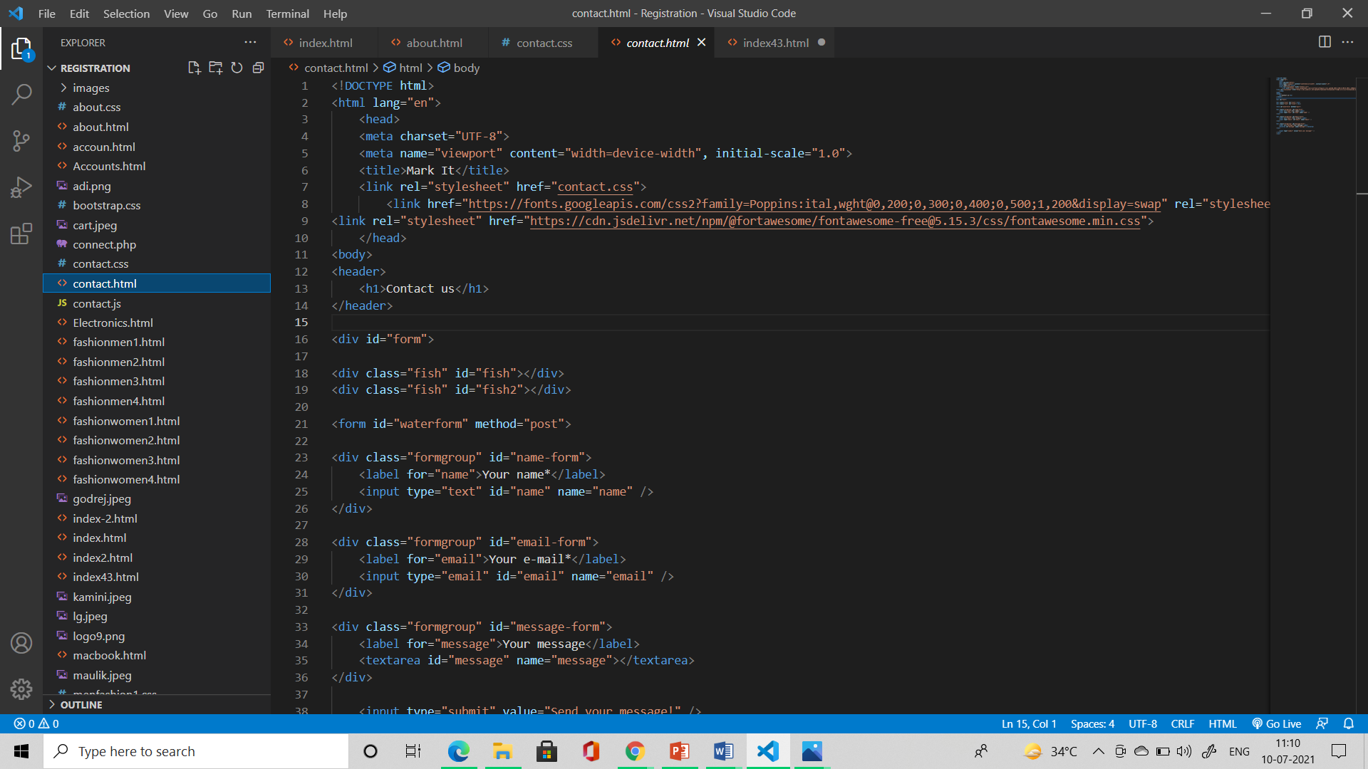

**Fig 3.3.5 Contact**

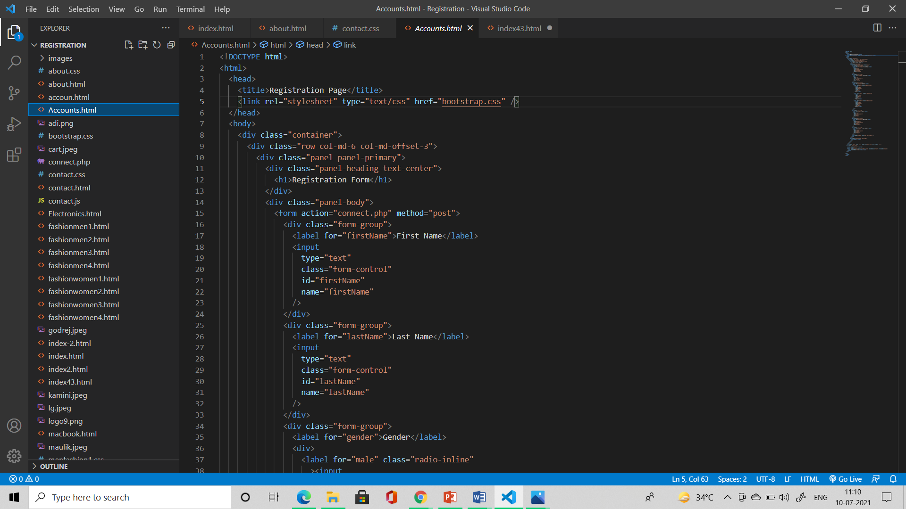

**Fig 3.3.6 Accounts**

### CHAPTER 4

###### CONCLUSION AND FUTURE SCOPE

Our project is only a humble venture to satisfy the needs to manage their project work. Several user friendly coding has also been adopted. The objective of the software planning is to provide a framework with a limited project completion time frame at the beginning of the project and should be updated on a regular basis.

### POSSIBLE FUTURE WORK

* + - We can give more advance software for Ecommerce Website systems and add more facilities.
    - We can add ‘add to cart’ option in the future.
    - We can add the ‘buy now’ option and make it linked to database system in the future.
    - Create a backup mechanism for backing up data and information.
    - We will host the platform on online servers, to make it accessible worldwide.
    - Today, the market place is flooded with several Ecommerce website options for shoppers to choose from.
    - A variety of more innovative products can be added to the website.
    - Today, it is a reality in India, in the last couple of years, the growth of Ecommerce website industry in India has been phenomenal as more shoppers have started discovering the benefits of using this platform.
    - There is enough scope for online businesses in the future if they understand the Indian shoppers psyche and cater to their needs.

##### REFERENCES

[1] By [Larry Ullman](https://www.google.co.in/search?hl=en&sxsrf=ALeKk01_YRSPRVGKiX3xSE0L6S6R503PvA:1625896832868&q=inauthor:%22Larry+Ullman%22&tbm=bks) · 2010 Effortless E-Commerce with PHP and MySQL.

[2] By [Max Bramer](https://www.google.co.in/search?hl=en&sxsrf=ALeKk03WDMPVChJkLCGaWgEEadg-Pq7dLQ:1625896967606&q=inauthor:%22Max+Bramer%22&tbm=bks) · 2015 Web Programming with PHP and MySQL A Practical Guide.

[3] By [Anne Nelson](https://www.google.co.in/search?hl=en&sxsrf=ALeKk03NVVsqZw5x3pSIFVPr79g-vFF4rw:1625897091736&q=inauthor:%22Anne+Nelson%22&tbm=bks), [William H. M. Nelson](https://www.google.co.in/search?hl=en&sxsrf=ALeKk03NVVsqZw5x3pSIFVPr79g-vFF4rw:1625897091736&q=inauthor:%22William+H.+M.+Nelson%22&tbm=bks) · 2002 Building Electronic Commerce with Web Database Constructions.

[4] [James McGaw](https://www.google.com/search?sa=X&biw=1536&bih=754&tbm=bks&sxsrf=ALeKk02q4s3zzNs3MJaMDBgDaRK7UVluPA:1625896959297&tbm=bks&q=inauthor:%22James+McGaw%22&ved=2ahUKEwjbz8yV6tfxAhVCQH0KHelqA6wQ9AgwBHoECAkQBQ) · 2010 [Beginning Django E-Commerce](https://books.google.co.in/books?id=LwO1GzMN_QsC&printsec=frontcover&dq=how+to+create+ecommerce+website+using+html+and+database&hl=en&newbks=1&newbks_redir=1&sa=X&ved=2ahUKEwjbz8yV6tfxAhVCQH0KHelqA6wQ6AEwBHoECAkQAg).

[5] By [Janice Reynolds](https://www.google.co.in/search?hl=en&sxsrf=ALeKk022YF72p4r9vCxYmmDipyw9zyBbQg:1625897524338&q=inauthor:%22Janice+Reynolds%22&tbm=bks) · 2004 The Complete E-Commerce Book Design, Build & Maintain a Successful Web-based Business.

[6] By [Matthew MacDonald](https://www.google.co.in/search?hl=en&sxsrf=ALeKk018E7aCiE2dwhH2qA7GNtS6z8Y6SQ:1625897589498&q=inauthor:%22Matthew+MacDonald%22&tbm=bks) · 2015 Creating a Website: The Missing Manual.